Final Report
- Background:
The topic I have chosen for my research is the National Basketball Association (NBA), the major professional basketball league in the United States.
- Over the years, the number of teams participating in the league has steadily increased, growing from 22 teams in 1980 to 30 teams by 2025.
- In a typical NBA season, each team plays 82 games. However, some seasons included fewer games due to exceptional circumstances, such as league lockouts or the COVID-19 pandemic.
- In 1976, the NBA merged with the American Basketball Association (ABA), creating a single unified league. Because individual player statistics have remained largely consistent since 1980, I chose this year as the starting point for my research.

- Question:
The original question I intended to investigate was: “Can an NBA team’s total number of regular-season wins be predicted from the aggregated individual statistics of its players?” During the analysis, however, I refined the question to: “Can an NBA team’s regular-season win percentage be predicted from the aggregated individual statistics of its players?”
The two questions are very similar, but they differ in the target variable being predicted: total wins versus win percentage. In most seasons this distinction would not significantly affect the results because teams typically play 82 games. However, several seasons had fewer games due to circumstances such as lockouts or the COVID-19 pandemic.For this reason, I chose to focus on win percentage instead of total wins. Using win percentage creates a consistent measure across all seasons, allowing the data to be compared fairly even when the number of games played differs.

- Methods:
In my project I used four main methods:
- Data Collection and cleaning:
I collected all necessary data for the years 1980–2025 from Basketball Reference (https://www.basketball-reference.com/), including individual player statistics, team rosters, and team rankings.
The data was gathered manually from the website, which provides the option to copy the displayed tables in .csv format. I then combined these tables together into a the three datasets I needed.
Since the website provides statistics for individual seasons, I added a Year column to the dataset to distinguish between different seasons, ensuring that each row could be correctly associated with its respective year.

- Exploratory Data Analysis (EDA):
I first checked all datasets for duplicate rows and found none. I also examined the data for missing values. Missing values were present only in the individual player statistics dataset, specifically in the GS (games started) and Awards (individual end-of-season awards) columns. I chose to disregard these missing values, as these columns were not used in the correlation analysis or modeling stages of the project.
Additionally, I plotted each team’s win percentage over the years. This allowed me to visually identify irregularities or patterns that could indicate data errors, anomalies, or trends that might be useful in the subsequent correlation analysis and predictive modeling.
After cleaning and visualizing the data, I created the aggregated dataset that I will use to answer my research question. For each team, I summed the individual statistics of all players on the roster from the previous season. I included all player statistics that could be meaningfully aggregated and also derived additional team-level metrics based on these aggregated values, such as True Shooting Percentage (TS_pct), Effective Field Goal Percentage (eFG_pct), and Assist-to-Turnover Ratio (AST_TOV_ratio).

- Correlation Analysis:
In this stage, I examined whether any of the aggregated team-level features were correlated with win percentage. I first calculated a correlation matrix using data from all years (1980–2025) and found correlations ranging from 0.1 to 0.38, which are relatively weak.
To account for changes in playing style over time, I then split the data into three eras: 1980–1995, 1995–2010, and 2010–2025. After splitting the data, correlations improved slightly: 0.09–0.54 for 1980–1995, 0.11–0.41 for 1995–2010, and 0.13–0.42 for 2010–2025. Across all eras, the feature that most consistently showed the highest correlation was True Shooting Percentage (TS_pct). In general, the top correlated features tended to reflect team efficiency.
I also plotted each normalized feature against win percentage for each era to visually inspect potential linear relationships. Most of the plots appeared as “clouds,” showing no clear linear correlation, indicating that no single feature alone could reliably predict win percentage.

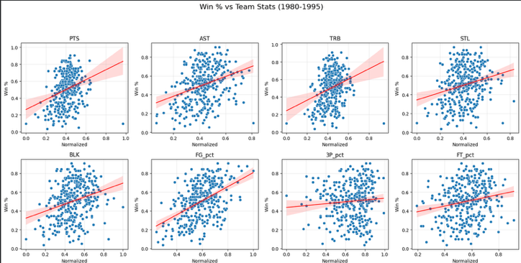
‘cloudy’ linear correlation:

- Predictive Modeling:
In this stage, I used three models: Linear Regression, Ridge Regression, and Random Forest. Ridge Regression was recommended to me by ChatGPt because it can improve predictions when features are correlated, which is common in basketball datasets. Ridge adds a penalty to large coefficients to reduce overfitting, produce more stable predictions, and better handle correlated features.
I chose these models because my target variable, win percentage, is continuous, making regression models more appropriate than clustering approaches. For all tests, I split the data into training (approximately 75%) and testing (approximately 25%) sets.
First, I applied the models to the entire dataset, using 1980–2015 for training and 2016–2025 for testing. All three models performed poorly, yielding results worse than a baseline random prediction.
Next, I split the data by eras (1980–1995, 1995–2010, 2010–2025) and ran the models independently for each era. This produced better results:
- Linear Regression achieved an R² of 0.42 for 1980–1995.
- Ridge Regression achieved an R² of 0.96 for 1995–2010.
- For 2010–2025, all models still performed worse than baseline, with Random Forest being the best at R² = -0.14.
Finally, I reran the models using only the best-correlated features for each era. This did not improve performance; all models performed worse than when using all features.

- Results:
The results indicate that, in most cases, the models performed poorly, with weak predictive power at best. Despite trying multiple approaches—including using all features, splitting the data by era, and selecting only the most correlated features—the highest R² achieved was 0.41.
Both the correlation analysis and the modeling showed improved results when the data was split into different eras, as reflected in the correlation matrices and the era-specific model performances:
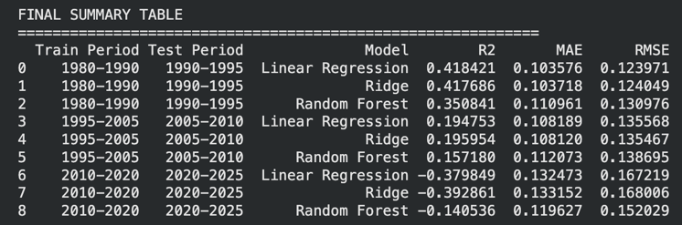
Models using all the years:
Splitting into different eras:
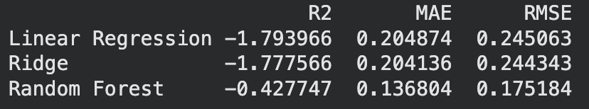

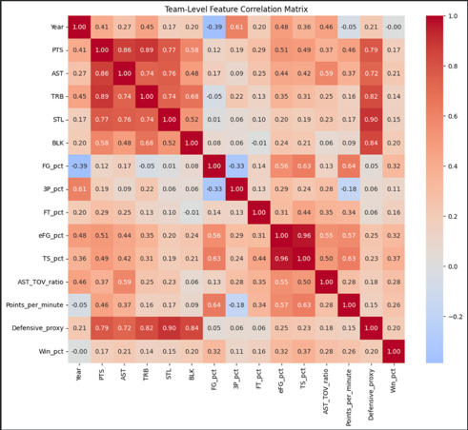
All the years (1980-2025):

Spilt into eras:

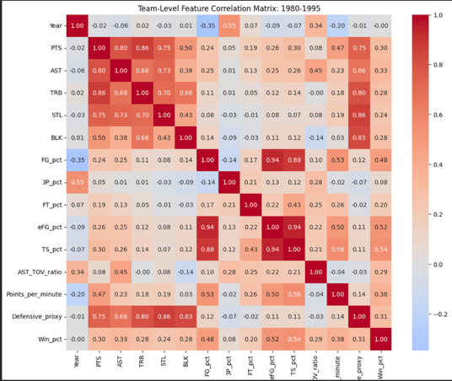
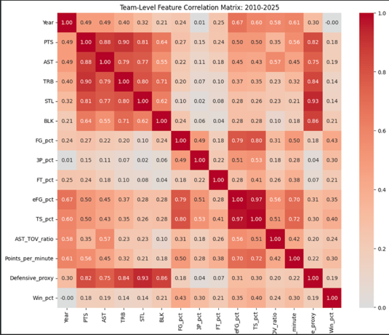
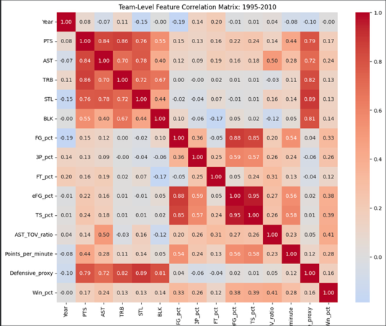

Overall, even the best-performing models were not able to achieve satisfactory accuracy, indicating that predicting team win percentage from aggregated individual player statistics is highly challenging and may not be reliably possible with the features used.

- Discussion:
The results indicate that predicting an NBA team’s win percentage from aggregated individual player statistics is generally unreliable. Models such as Linear Regression, Ridge, and Random Forest achieved weak performance, with the highest R² only 0.41. Correlation analysis showed that efficiency metrics like True Shooting Percentage (TS_pct) were the most predictive, but most features had weak or nonlinear relationships, limiting the ability to forecast outcomes.
Splitting the data by era improved correlations and model performance slightly, suggesting that changes in playing style over time affect the relationship between player stats and team success. While the approach—aggregating player stats and testing multiple regression models—was reasonable, it did not fully capture important factors like coaching, injuries, player synergy, or schedule difficulty.
These findings imply that individual statistics alone are insufficient for accurate predictions. To better answer the question, future work could include advanced metrics capturing team interactions, game-by-game data, or qualitative factors. In its current form, the study shows the complexity of basketball and highlights that predicting team success requires more comprehensive data and modeling approaches.

